# COMP 214 Game Design Document Date: November 20, 2014

In Attendance: Matt, Bennat, Pat, Roshan, Crystal

Regrets: n/a

# Working Title: Caveman Game

## Description

Side scrolling action adventure 2D platform single player game in a fantasy world of a caveman trying to rescue a cave princess by battling prehistoric villains.

## Game Play Overview

The game will be designed to be just difficult enough to be truly challenging, while allowing players to achieve small accomplishments that compel them to keep playing. The design of the game will allow the player to have small “wins” to keep them playing. There will be hooks that will be built into the game with the intent of making it more addictive, such as getting the highest score, opposing enemies, challenging obstacles, power ups and beating the game.

## Quantifiable Elements

One big huge level with the screen focused to the single player (center view on player). There will be checkpoints to save your spot in the game.

* Characters
  + 1 main guy - caveman
  + 2 Obstacles
    - Fire
    - Plant
    - Something from above (vines or flying bat) - wishlist
  + Common enemies
    - 1 enemy
    - 2 enemy - wishlist
  + 1 boss
    - Shoots fireballs
  + Characters – wishlist
    - Cave babe
    - Mammoth
    - Flying animal (bat, pterodactyl)
    - Dinosaur
  + Sprites
    - <http://opengameart.org/content/running-caveman-spritesheet>
    - <http://www.vg-resource.com/thread-9729-page-2.html>
* Screens
  + Splash Screen
  + Menu Screen
  + Pause Screen - wishlist
  + Game Over Screen
    - Grab girl and drag by hair - wishlist
    - Show Score
    - The End
      * You died
      * You win
    - Credit Screen
  + Game Play
    - Side Scrolling
    - Storyline - wishlist
      * Dinosaur destroys village
      * steals girl
* Levels
  + One big level
  + checkpoints (save state) - wishlist
* Game Play
  + 2-3 power-ups - wishlist
    - Flaming stick
    - Uni-wheel
  + Pick Up items - wishlist
  + No timer
  + Score
  + Health
* Weapons, Obstacles, projectiles and Objects - wishlist
  + Club
  + Fire
  + Bones
  + Stone axe – keep in scope
  + torch
  + Vines
  + Stones
  + Diamonds
  + Sticks
  + Spears
  + Rocket (Cheat Codes)
* Music
  + Bongos
  + Background image (tiled out screen)
* Character actions
  + Running – right
  + Running – left (rotate right facing)
  + Throwing weapon
  + Jumping
  + Weapon throwing animation - wishlist
  + Attack animation – wishlist
  + Crouching animation – wishlist
  + Death animation - wishlist
* Character Names
  + Atouk
  + Tumak
  + Bork
* Game Names
  + Stone Age
  + Mattock – tool for striping meat or blubber

### Preliminary Risk & Additional Concerns

The assets and resources we may have difficult time securing are the sprites, storylines and the knowledge we need to acquire will be getting familiar with GameMaker and GIMP programs. The Attendance issues that may arise are sick kids and/or team members.

## Sign Off

Matt Kennedy Pat Dunne

Bennat Parappuram Roshan Sharma

Crystal Fatteicher

Craig Nielsen Gavin Osborne

## Attachments

Joe n Mac has caveman ninja has a lot of sprites we could utilize for our game; reference link below:

<http://www.spriters-resource.com/arcade/joenmac/>

http://www.vg-resource.com/thread-9729-page-2.html

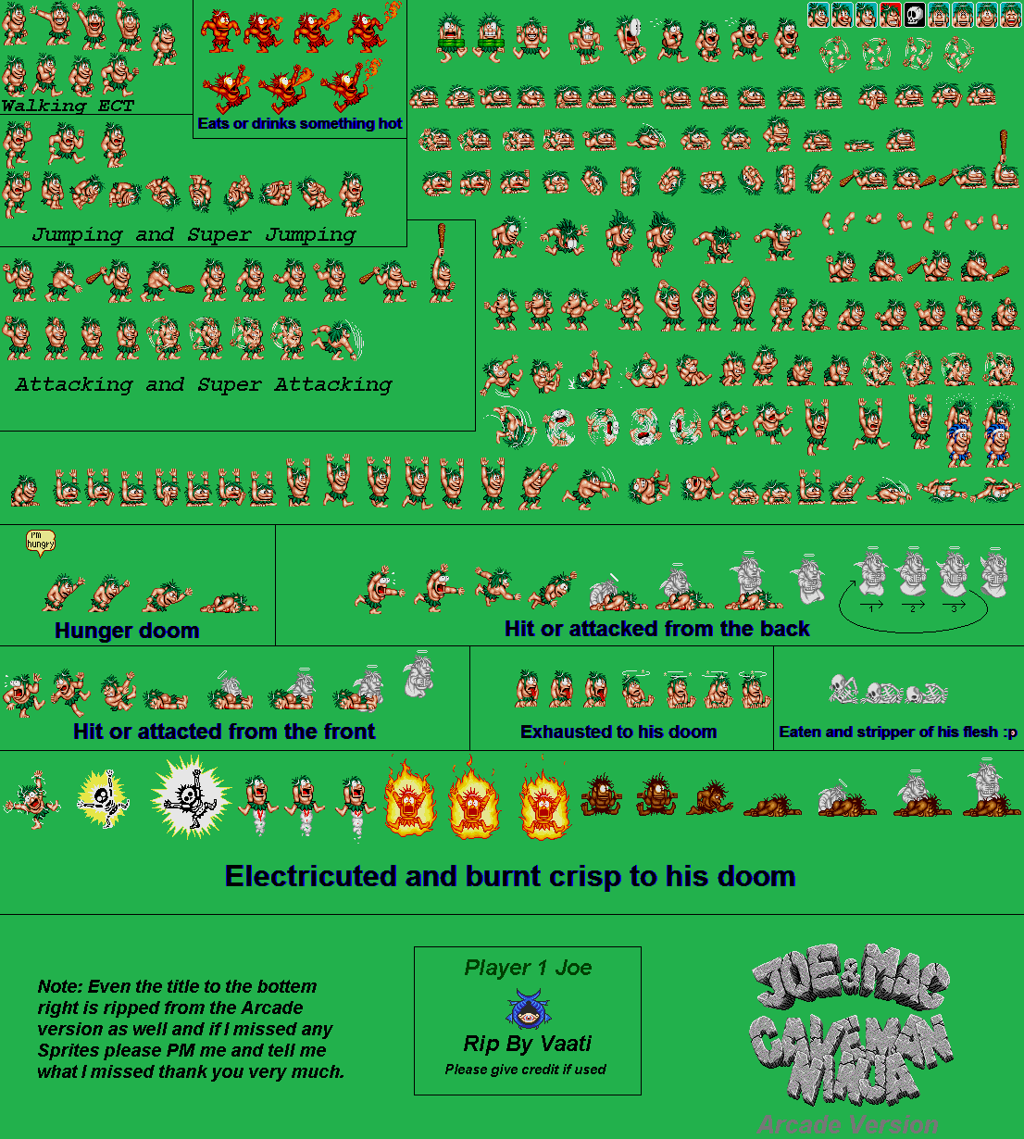

http://untamed.wild-refuge.net/images/rpgxp/shadowhearts/silverbat.png

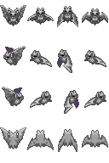

<http://www.spriters-resource.com/download/55446/>

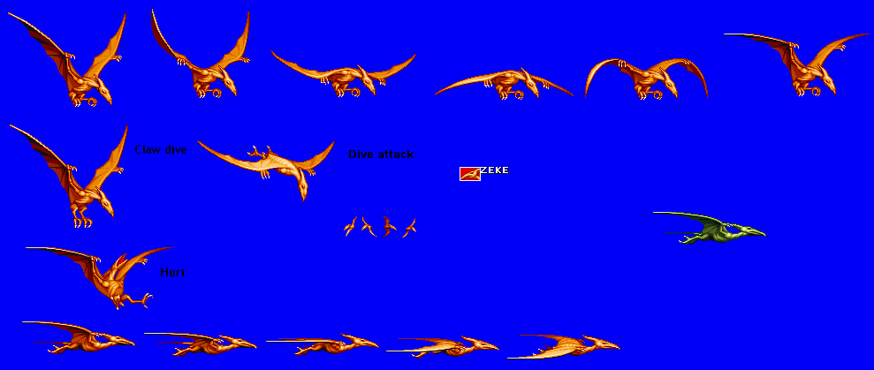

[http://spritedatabase.net/files/ps2/902/Sprite/Velociraptor.gif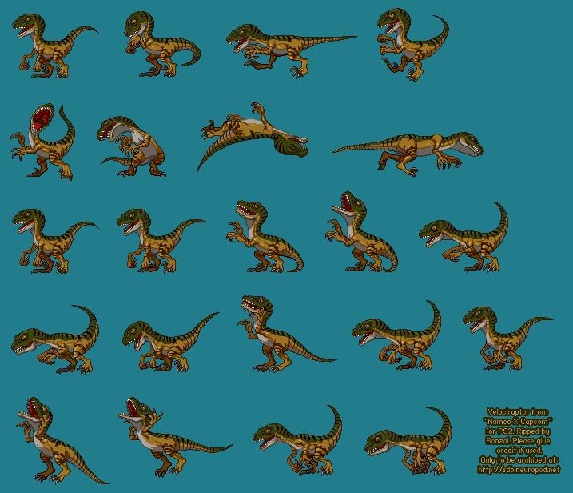](http://spritedatabase.net/files/ps2/902/Sprite/Velociraptor.gif)

http://spritedatabase.net/files/snes/430/Sprite/Trex.png

